* <https://www.youtube.com/watch?v=3sMxJxeUOLg>
* 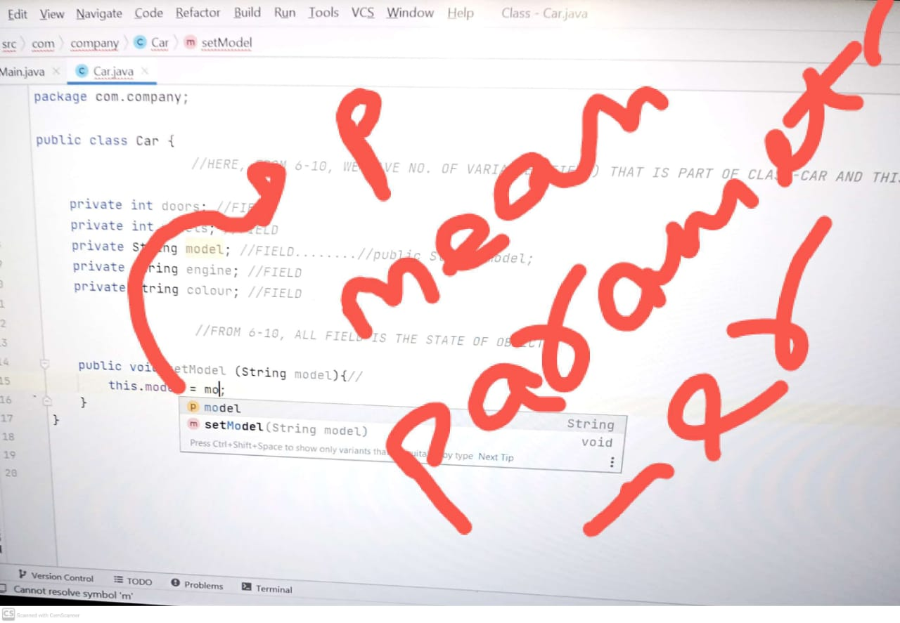

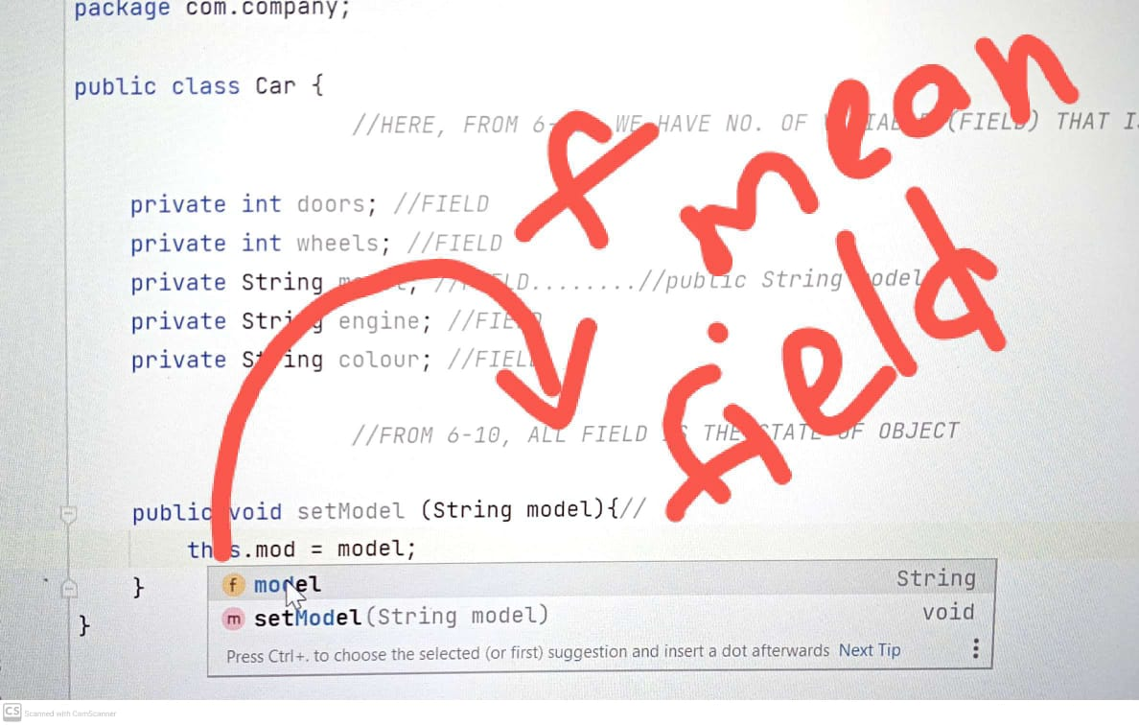

* Jaha par f and p likha hai jo ki yeh batata hai yeh field hai and woh parameter. Uske saath lock bana rahta hai kabhi kabhi jo yeh batata hai ki who private hai(jab lock band rahta hai)

and public batata hai jab woh lock open rahta hai

* Agar c likha hota hai matlab class hai.
* Waise orr bhi hota hai jaise v, and so on………….